User Data Comparison Process

  - Author: Oscar Ferne

Overview

This Document outlines the process for comparing two sets of user data. Typically, this process is used to compare user data as it will appear before and after a full sync on a recently updated MA.

Required Material / Tools

- CSV export of the original data
- CSV export of the updated data
- Beyond Compare: download here - http://www.scootersoftware.com/download.php

Comparison Process

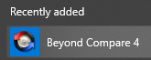
- Open Beyond Compare

- In the top right corner use the ‘Session’ menu to create a new session. Select the Table Compare for CSV comparisons.
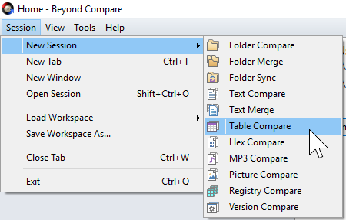

- This will load in a new session. To begin a comparison of user data first take a csv of the original data export and load it into the left text field, either by dragging it across or by selecting the folder icon on the top right of the text field and navigating to the file you wish to load in.

- Before comparing the data, the primary key must be set. In this example the sAMAccount name was used. Select the primary key by right clicking the column and selecting the ‘Key Column’ option. If an incorrect key column was selected by default, ensure that it is switched back to a ‘Standard Column’. A key symbol will indicate what the column is set to.
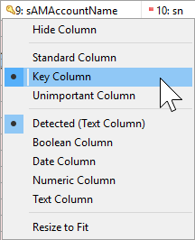
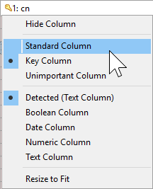

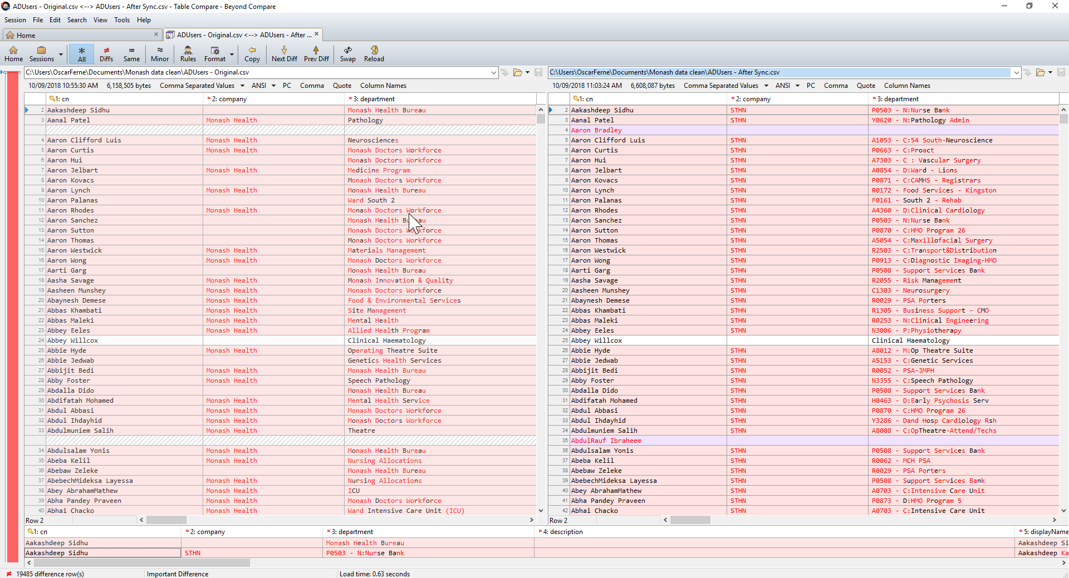
The data is now correctly displaying a comparison.

Formatting Rules
The formatting rules are as follow:
- Red Highlight representing Updated
- White Highlight representing Unchanged
- Purple Highlight representing Added
- Red Text representing Updated
- Black Text representing Unchanged

Reports
- If the comparison is required as a deliverable a report can be generated to list the information. To generate the report, click on the ‘Session’ menu and select the ‘Table Compare Report…’.
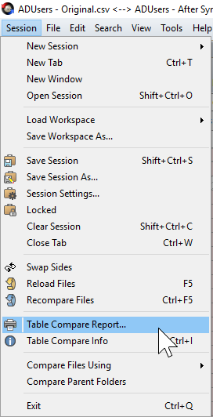

- Configure the preferred output and save the report.
Note: When viewing a side by side report there is a column separating the two tables. Between the two sets there are symbols that represent the following:
- = representing Equals
- <> representing Updated
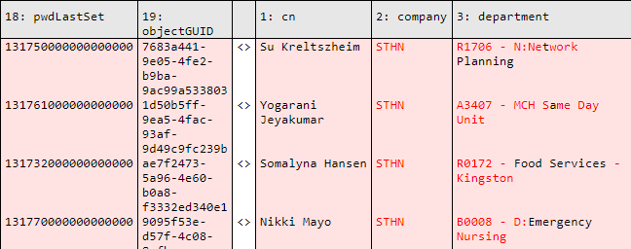
- -+ representing User Added

